Patient Case Report Form

Pharmacogenetic analysis in pediatric/adolescent
Hematologic-oncologic disease

Principal Investigator:

1. BASIC DATA
Organization | _______________________________
Subject No. | _______________________________
Sex | ____________M / F_______________
Date of Birth :
 | YEAR |  |  |  |  | MONTH |  |  | DAY

2. DIAGNOSIS
Diagnosis | _______________________________(see #1)
Date of Initial Diagnosis :
 | YEAR |  |  |  |  | MONTH |  |  | DAY

3. TREATMENT

Date of Treatment start :
 | YEAR |  |  |  |  | MONTH |  |  | DAY
Chemotherapy History
(ex. “0601 consolidation” “maintenance #1, #2”, not “HR 0601”)

Protocol | Start date | End date

Hematopoietic stem cell transplantation

□ No
□ Yes
□ Allogeneic □ Autologous
Date of HSCT
 | YEAR |  |  |  |  | MONTH |  |  | DAY
Conditioning regimen | START DATE |  |  |  |  |  |  |  |  |  |  |  | END DATE
 | YEAR |  |  |  |  | MONTH |  |  | DAY |  |  |  | YEAR |  | MONTH |  | DAY
GVHD prophylaxis | □ No □ Yes  □ ATG (after d0)  □ Corticosteroids  □ Cyclosporine (CSA)  □ FK506  □ MTX  □ MMF  □ Cyclophosphamide (CPM)  □ Other drug, specify:_________________

Was there further HSCT?
□ No
□ Yes
□ Allogeneic □ Autologous
Date of HSCT
 | YEAR |  |  |  |  | MONTH |  |  | DAY
Conditioning regimen | START DATE |  |  |  |  |  |  |  |  |  |  |  | END DATE
 | YEAR |  |  |  |  | MONTH |  |  | DAY |  |  |  | YEAR |  | MONTH |  | DAY
GVHD prophylaxis | □ No □ Yes  □ ATG (after d0)  □ Corticosteroids  □ Cyclosporine (CSA)  □ FK506  □ MTX  □ MMF  □ Cyclophosphamide (CPM)  □ Other drug, specify:_________________

Was there further HSCT?
□ No
□ Yes

----- CRF 1 끝 (한번 입력받고 끝) ------

입력되는 값이 1회성인 것 (basic data, diagnosis, treatment)과
EMR에서 주기적으로 업데이트 되는 것 (medication, lab history, 신체계측, adverse events)
이렇게 2가지로 분류되어 CRF 2 페이지로 제작되면 좋을 것 같아 구분하였습니다.

1. Medication History
약품명 | 투여용량 | 단위 | 투여경로 | 처방시작일 | 처방종료일
정맥(IV)
경구(PO)
척수강내(IT)
기타: ______
정맥(IV)
경구(PO)
척수강내(IT)
기타: ______
정맥(IV)
경구(PO)
척수강내(IT)
기타: ______

2. Laboratory History
Use following Lab:
Amylase, ANC, aPTT, BUN, Calcium, Cholesterol, Cr, Direct Bilirubin, Glucose, GOT (AST), GPT (ALT), Hb, K, Lipase, Magnesium, Na, Phosphorus, PLT, PT, Total Bilirubin, Triglyceride, WBC, Cardiac troponin I, NT-proBNP, CK-MB
검사일 | 검사명 | 검사결과 | 검사단위

3. 신체계측

측정일 | Body weight | Height | BSA

4. Adverse Events (CTCAE 4.0)

Lab test related Adverse Event

*Use following lab:
Complete Blood Counts: Anemia (Hb), Leukopenia (WBC), Neutropenia (ANC), Thrombocytopenia (PLT)
Chemistry & Coagulation & Urine: aPTT 연장, PT INR 증가, ALT or GPT 증가, AST or GOT 증가, Bilirubin 상승, Cholesterol증가, Creatinine 상승, Amylase 증가, Lipase 증가, Ca 증가, Ca 감소, Glucose 증가, Glucose 감소, K 증가, K 감소, Mg 증가, Mg 감소, Na 증가, Na 감소, TG 증가, Uric acid 증가, Albumin 감소, P 감소, Cardiac troponin I 증가, NT-proBNP, CK-MB
발생일 | 검사분류* | 검사관련 이상반응* | Adverse Event Grade
 | Complete Blood Counts  Chemistry & Coagulation & Urine |  | Gr3  Gr4
 | Complete Blood Counts  Chemistry & Coagulation & Urine |  | Gr3  Gr4
 | Complete Blood Counts  Chemistry & Coagulation & Urine |  | Gr3  Gr4
 | Complete Blood Counts  Chemistry & Coagulation & Urine |  | Gr3  Gr4

Symptom related Adverse Event

*Use following symptoms/diseases:
Allergy & Rash: Allergic reaction, Anaphylaxis, Injection site reaction, Rash maculo-papular, Urticaria, Stevens-Johnson syndrome
Fever & Infection: Febrile neutropenia, Fever without neutropenia, Sepsis
Cardiovascular: Ejection fraction 감소, Heart failure, Hypertension, Hypotension, Myocarditis, Pericardial effusion, Pericarditis, Thromboembolic event
Gastrointestinal: Constipation, Diarrhea, Hepatic failure, Ileus, Mucositis oral, Pancreatitis, Gastrointestinal hemorrhage
Neurologic: Encephalopathy, Leukoencephalopathy, Peripheral motor neuropathy, Peripheral sensory neuropathy, Seizure
Other: Pneumonitis, Avascular necrosis, Cytokine releasing syndrome, Osteonecrosis of jaw, Osteoporosis, Cataract, Hearing impaired, Blurred vision, Other disorders - specify
발생일 | 분류 | 질병관련 이상반응 | 발생여부 | If 이상반응 발생시,  CTCAE grade
 | Allergy & Rash  Fever & Infection  Cardiovascular  Gastrointestinal  Neurologic  Other | Allergic reaction | Yes  NO | Grade 1  Grade 2  Grade 3  Grade 4  Grade 5  Unknown
 | Allergy & Rash  Fever & Infection  Cardiovascular  Gastrointestinal  Neurologic  Other |  | Yes  NO | Grade 1  Grade 2  Grade 3  Grade 4  Grade 5  Unknown
 | Allergy & Rash  Fever & Infection  Cardiovascular  Gastrointestinal  Neurologic  Other |  | Yes  NO | Grade 1  Grade 2  Grade 3  Grade 4  Grade 5  Unknown

 | 질병관련이상반응 | 발생여부 | 이상반응  발생시작일 | Grade
 |  |  |  | 1 |  | 2 |  | 3 |  | 4 | Unknown
Allergy & Rash
No  Yes | Allergic reaction
 | Anaphylaxis
 | Injection site reaction
 | Rash maculo-papular
 | Urticaria
 | Stevens-Johnson syndrome
Fever & Infection
No  Yes | Febrile neutropenia
 | Fever without neutropenia
 | Sepsis
Cardiovascular
No  Yes | Ejection fraction 감소
 | Heart failure
 | Hypertension
 | Hypotension
 | Thromboembolic event
Gastrointestinal
No  Yes | Diarrhea
 | Hepatic failure
 | Ileus
 | Mucositis oral
 | Pancreatitis
 | Lower Gastrointestinal hemorrhage
 | Upper Gastrointestinal hemorrhage
Respiratory
No  Yes | Pneumonitis
 | Retinoic acid syndrome
 | Pulmonary fibrosis
 | Bronchopulmonary hemorrhage
 | Bronchospasm
Neurologic
No  Yes | Encephalopathy
 | Leukoencephalopathy
 | Peripheral motor neuropathy
 | Peripheral sensory neuropathy
 | Seizure
Renal, urinary
No  Yes | Acute kidney injury
 | Thrombotic thrombocytopenia purpura
 | Hemolytic uremic syndrome
 | Cystitis noninfective
Others
No  Yes | Avascular necrosis
 | Osteonecrosis of jaw
 | Osteoporosis
 | Cataract
 | Hearing impaired
 | Blurred vision
 | Psychosis
Other disorders - specify

Adverse Events Reference (CTCAE 4.03)

Complete Blood Counts | Grade 3 | Grade 4
Anemia (Hb) | Hgb <8.0 g/dL or <4.9 mmol/L or <80 g/L
Leukopenia (WBC) | 1000 - 2000/mm³ or 1.0 - 2.0 x 10⁹ /L | <1000/mm³ or <1.0 x 10⁹ /L
Neutropenia (ANC) | 500 - 1000/mm³ or 0.5 – 1.0 x 10⁹ /L | <500/mm³ or <0.5 x 10⁹ /L
Thrombocytopenia (PLT) | 25,000 - 50,000/mm³ or 25.0 - 50.0 x 10⁹ /L | <25,000/mm³; <25.0 x 10⁹ /L
Chemistry & Coagulation  & Urine | Grade 3 | Grade 4
aPTT 연장 | >2.5 x ULN; hemorrhage | -
PT INR 증가 | >2.5 x ULN | -
ALT or GPT 증가 | 5.0 - 20.0 x ULN | 20.0 x ULN
AST or GOT 증가 | 5.0 - 20.0 x ULN | 20.0 x ULN
Bilirubin 상승 | 3.0 - 10.0 x ULN | 10.0 x ULN
Cholesterol증가 | 400 - 500 mg/dL or 10.34 - 12.92 mmol/L | >500 mg/dL or >12.92 mmol/L
Creatinine 상승 | 3.0 - 6.0 x ULN | >6.0 x ULN
Amylase 증가 | 2.0 - 5.0 x ULN | >5.0 x ULN
Lipase 증가 | 2.0 - 5.0 x ULN | >5.0 x ULN
Ca 증가 | Corrected serum calcium of 12.5 - 13.5 mg/dL or 3.1 - 3.4 mmol/L  or Ionized calcium 1.6 - 1.8 mmol/L | Corrected serum calcium of >13.5 mg/dL or >3.4 mmol/L  or Ionized calcium >1.8 mmol/L
Ca 감소 | Corrected serum calcium of 6.0 - 7.0 mg/dL or 1.5-1.75 mmol/L  or Ionized calcium 0.8 - 0.9 mmol/L | Corrected serum calcium of <6.0 mg/dL or <1.5 mmol/L  or Ionized calcium <0.8 mmol/L
Glucose 증가 | 250 - 500 mg/dL or 13.9 - 27.8 mmol/L | >500 mg/dL or >27.8 mmol/L
Glucose 감소 | 30 - 40 mg/dL or 1.7-2.2 mmol/L | <30 mg/dL or <1.7 mmol/L
K 증가 | 6.0 - 7.0 mmol/L | >7.0 mmol/L
K 감소 | 2.5 - 3.0 mmol/L | <2.5 mmol/L
Mg 증가 | 3.0 - 8.0 mg/dL or 1.23 - 3.30 mmol/L | >8.0 mg/dL or >3.30 mmol/L
Mg 감소 | 0.7 - 0.9 mg/dL or 0.3 - 0.4 mmol/L | <0.7 mg/dL or <0.3 mmol/L
Na 증가 | 155 - 160 mmol/L | >160 mmol/L
Na 감소 | 120 - 130 mmol/L | <120 mmol/L
TG 증가 | 500 - 1000 mg/dL or 5.7 - 11.4 mmol/L | >1000 mg/dL or >11.4 mmol/L
Uric acid 증가 | ULN - 10 mg/dL (0.59 mmol/L) | >10 mg/dL or >0.59 mmol/L
Albumin 감소 | <2 g/dL, <20 g/L
P 감소 | 1.0 – 2.0 mg/dL or 0.3 – 0.6 mmol/L | <1.0 mg/dL or <0.3 mmol/L
cardiac troponin I 증가 | Levels above UNL
NT-proBNP | Levels above UNL
CK-MB | Levels above UNL

8. LAST FU

Treatment status

□ On treatment
□ Completed
Date of Therapy completed:
(최종 치료 종료일) | YEAR |  |  |  |  | MONTH |  |  | DAY

Event
□ No
□ Relapse
Date of Relapse
 | YEAR |  |  |  |  | MONTH |  |  | DAY
□ Death
Date of Death
 | YEAR |  |  |  |  | MONTH |  |  | DAY
□ 2ndary malignancy or MDS, diagnosis _____________________(see #1)

Date of Diagnosis
 | YEAR |  |  |  |  | MONTH |  |  | DAY

Survival
□ Alive
□ Dead, cause of death ________________________________________
□ Related with drug adverse event, the drug was_______________
□ Not related

Date of last FU
 | YEAR |  |  |  |  | MONTH |  |  | DAY

#1. Diagnosis
1 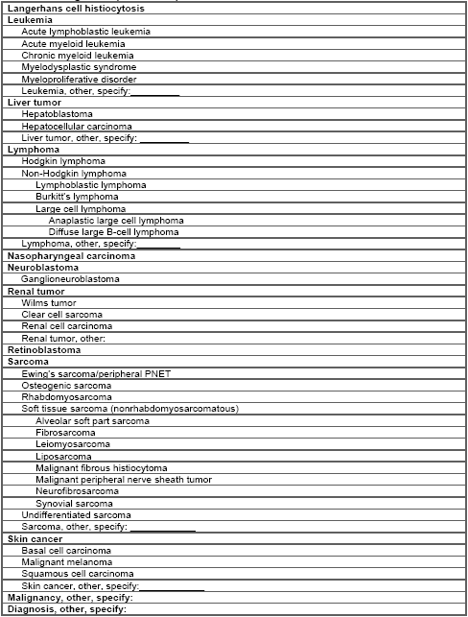
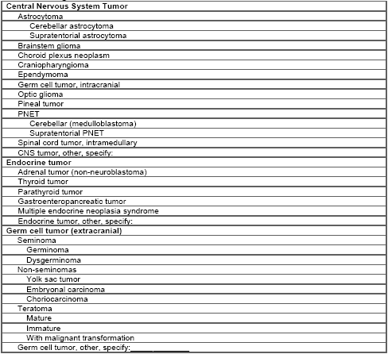

Creatinine
Age | ? | ?
2–3 years | 0.2–0.7 (17.7–61.9) | 0.3–0.6 (26.5–53.0)
4–7 years

Creatinine
2–3 years 0.2–0.7 (17.7–61.9) 0.3–0.6 (26.5–53.0)
4–7 years 0.2–0.8 (17.7–70.7) 0.2–0.7 (17.7–61.9)
8–10 years 0.3–0.9 (26.5–79.6) 0.3–0.8 (26.5–70.7)
11–12 years 0.3–1.0 (26.5–88.4) 0.3–0.9 (26.5–79.6)
13–17 years 0.3–1.2 (26.5–106.1) 0.3–1.1 (26.5–97.2)
18–20 years 0.5–1.3 (44.2–115.0) 0.3–1.1 (26.5–97.2)
Alkaline phosphatase
2–5 years 115–391 115–391
6–7 years 115–460 115–460
8–9 years 115–345 115–345
10–11 years 115–336 115–437
12–13 years 127–403 92–336
14–15 years 79–446 78–212
16–18 years 58–331 35–124
Phosphorus
1 year: 3.8–6.2 mg/dL (1.23–2.0 mmol/L)
10 years: 3.6–5.6 mg/dL (1.16–1.81 mmol/L)
Adults: 3.1–5.1 mg/dL (1.0–1.65 mmol/L)

