Patient Case Report Form

Pharmacogenetic analysis in pediatric/adolescent
Hematologic-oncologic disease

Principal Investigator:

1. BASIC DATA
Organization | _______________________________
Subject No. | _______________________________
Sex | ____________M / F_______________
Date of Birth :
 | YEAR |  |  |  |  | MONTH |  |  | DAY

2. DIAGNOSIS
Diagnosis | _______________________________(see #1)
Date of Initial Diagnosis :
 | YEAR |  |  |  |  | MONTH |  |  | DAY

3. TREATMENT

Date of Treatment start :
 | YEAR |  |  |  |  | MONTH |  |  | DAY
Chemotherapy History
(ex. “0601 consolidation” “maintenance #1, #2”, not “HR 0601”)

Protocol | Start date | End date

Hematopoietic stem cell transplantation
□ No
□ Yes
Types | Date of HSCT | Start date of Conditioning regimen | End date of Conditioning regimen | GVHD prophylaxis Indicator | If yes, drug name for GVHD
Allogeneic  Autologous | YYYY-MM-DD | YYYY-MM-DD | YYYY-MM-DD | No  Yes | ATG  Corticosteroids  Cyclosporine (CSA)  FK506  MTX  MMF  Cyclophosphamide(CPM)  Other drug, specify: _______
Allogeneic  Autologous | YYYY-MM-DD | YYYY-MM-DD | YYYY-MM-DD | No  Yes | ATG  Corticosteroids  Cyclosporine (CSA)  FK506  MTX  MMF  Cyclophosphamide (CPM)  Other drug, specify: _______

1. Medication History
약품명 | 투여용량 | 단위 | 투여경로 | 처방시작일 | 처방종료일 | 처방기간 | 처방용법
 |  |  | 정맥(IV)  경구(PO)  척수강내(IT)  기타: ______ |  |  |  | 예)1일 2회
정맥(IV)
경구(PO)
척수강내(IT)
기타: ______
정맥(IV)
경구(PO)
척수강내(IT)
기타: ______

2. Laboratory History
Use following Lab:
Amylase, ANC, aPTT, BUN, Calcium, Cholesterol, Cr, Direct Bilirubin, Glucose, GOT (AST), GPT (ALT), Hb, K, Lipase, Magnesium, Na, Phosphorus, PLT, PT, Total Bilirubin, Triglyceride, WBC, Cardiac troponin I, NT-proBNP, CK-MB
검사일 | 검사명 | 검사결과 | 검사단위

3. 신체계측

측정일 | Body weight | Height | BSA

4. Adverse Events (CTCAE 4.0)

Lab test related Adverse Event

*Use following lab:
Complete Blood Counts: Anemia (Hb), Leukopenia (WBC), Neutropenia (ANC), Thrombocytopenia (PLT)
Chemistry & Coagulation & Urine: aPTT, PT INR, ALT or GPT, AST or GOT, Bilirubin, Cholesterol, Creatinine, Amylase, Lipase, Ca, Glucose, K, Mg, Na, TG, Uric acid, Albumin, P, Cardiac troponin I, NT-proBNP, CK-MB
발생일 | 검사분류* | 검사관련 이상반응* | Adverse Event Grade
 | Complete Blood Counts  Chemistry & Coagulation & Urine |  | Gr3  Gr4
 | Complete Blood Counts  Chemistry & Coagulation & Urine |  | Gr3  Gr4
 | Complete Blood Counts  Chemistry & Coagulation & Urine |  | Gr3  Gr4
 | Complete Blood Counts  Chemistry & Coagulation & Urine |  | Gr3  Gr4

Symptom related Adverse Event

*Use following symptoms/diseases:
Allergy & Rash: Allergic reaction, Anaphylaxis, Injection site reaction, Rash maculo-papular, Urticaria, Stevens-Johnson syndrome
Fever & Infection: Febrile neutropenia, Fever without neutropenia, Sepsis
Cardiovascular: Ejection fraction, Heart failure, Hypertension, Hypotension, Myocarditis, Pericardial effusion, Pericarditis, Thromboembolic event
Gastrointestinal: Constipation, Diarrhea, Hepatic failure, Ileus, Mucositis oral, Pancreatitis, Gastrointestinal hemorrhage
Neurologic: Encephalopathy, Leukoencephalopathy, Peripheral motor neuropathy, Peripheral sensory neuropathy, Seizure
Other: Pneumonitis, Avascular necrosis, Cytokine releasing syndrome, Osteonecrosis of jaw, Osteoporosis, Cataract, Hearing impaired, Blurred vision, Other disorders – specify

이상반응 (+)
질병관련 이상반응? (콤보박스)
CTCAE grade? (콤보박스)
발생날짜? ___________

8. LAST FU(Follow-Up)

Treatment status

□ On treatment
□ Completed
Date of Therapy completed:
(최종 치료 종료일) | YEAR |  |  |  |  | MONTH |  |  | DAY

Event
□ No
□ Relapse
Date of Relapse
 | YEAR |  |  |  |  | MONTH |  |  | DAY
□ Death
Date of Death
 | YEAR |  |  |  |  | MONTH |  |  | DAY
□ 2ndary malignancy or MDS, diagnosis _____________________(see #1)

Date of Diagnosis
 | YEAR |  |  |  |  | MONTH |  |  | DAY

Survival
□ Alive
□ Dead, cause of death ________________________________________
□ Related with drug adverse event, the drug was_______________
□ Not related

Date of last FU
 | YEAR |  |  |  |  | MONTH |  |  | DAY

Adverse Events Reference (CTCAE 4.03)

Complete Blood Counts | Grade 3 | Grade 4
Anemia (Hb) | Hgb <8.0 g/dL or <4.9 mmol/L or <80 g/L
Leukopenia (WBC) | 1000 - 2000/mm³ or 1.0 - 2.0 x 10⁹ /L | <1000/mm³ or <1.0 x 10⁹ /L
Neutropenia (ANC) | 500 - 1000/mm³ or 0.5 – 1.0 x 10⁹ /L | <500/mm³ or <0.5 x 10⁹ /L
Thrombocytopenia (PLT) | 25,000 - 50,000/mm³ or 25.0 - 50.0 x 10⁹ /L | <25,000/mm³; <25.0 x 10⁹ /L
Chemistry & Coagulation  & Urine | Grade 3 | Grade 4
aPTT 연장 | >2.5 x ULN; hemorrhage | -
PT INR 증가 | >2.5 x ULN | -
ALT or GPT 증가 | 5.0 - 20.0 x ULN | >20.0 x ULN
AST or GOT 증가 | 5.0 - 20.0 x ULN | >20.0 x ULN
Bilirubin 상승 | 3.0 - 10.0 x ULN | >10.0 x ULN
Cholesterol증가 | 400 - 500 mg/dL or 10.34 - 12.92 mmol/L | >500 mg/dL or >12.92 mmol/L
Creatinine 상승 | 3.0 - 6.0 x ULN | >6.0 x ULN
Amylase 증가 | 2.0 - 5.0 x ULN | >5.0 x ULN
Lipase 증가 | 2.0 - 5.0 x ULN | >5.0 x ULN
Ca 증가 | Corrected serum calcium of 12.5 - 13.5 mg/dL or 3.1 - 3.4 mmol/L  or Ionized calcium 1.6 - 1.8 mmol/L | Corrected serum calcium of >13.5 mg/dL or >3.4 mmol/L  or Ionized calcium >1.8 mmol/L
Ca 감소 | Corrected serum calcium of 6.0 - 7.0 mg/dL or 1.5-1.75 mmol/L  or Ionized calcium 0.8 - 0.9 mmol/L | Corrected serum calcium of <6.0 mg/dL or <1.5 mmol/L  or Ionized calcium <0.8 mmol/L
Glucose 증가 | 250 - 500 mg/dL or 13.9 - 27.8 mmol/L | >500 mg/dL or >27.8 mmol/L
Glucose 감소 | 30 - 40 mg/dL or 1.7-2.2 mmol/L | <30 mg/dL or <1.7 mmol/L
K 증가 | 6.0 - 7.0 mmol/L | >7.0 mmol/L
K 감소 | 2.5 - 3.0 mmol/L | <2.5 mmol/L
Mg 증가 | 3.0 - 8.0 mg/dL or 1.23 - 3.30 mmol/L | >8.0 mg/dL or >3.30 mmol/L
Mg 감소 | 0.7 - 0.9 mg/dL or 0.3 - 0.4 mmol/L | <0.7 mg/dL or <0.3 mmol/L
Na 증가 | 155 - 160 mmol/L | >160 mmol/L
Na 감소 | 120 - 130 mmol/L | <120 mmol/L
TG 증가 | 500 - 1000 mg/dL or 5.7 - 11.4 mmol/L | >1000 mg/dL or >11.4 mmol/L
Uric acid 증가 | ULN - 10 mg/dL (0.59 mmol/L) | >10 mg/dL or >0.59 mmol/L
Albumin 감소 | <2 g/dL or <20 g/L
P 감소 | 1.0 – 2.0 mg/dL or 0.3 – 0.6 mmol/L | <1.0 mg/dL or <0.3 mmol/L
cardiac troponin I 증가 | Levels above UNL
NT-proBNP | Levels above UNL
CK-MB | Levels above UNL

#1. Diagnosis
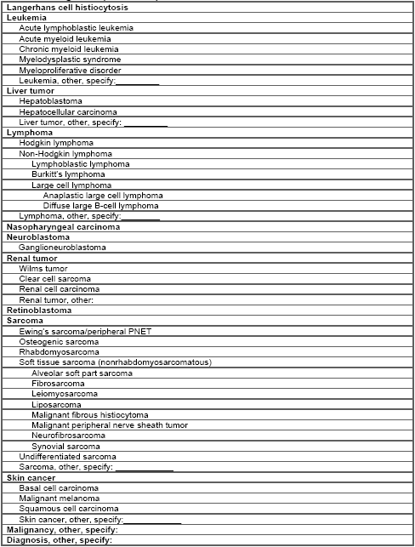

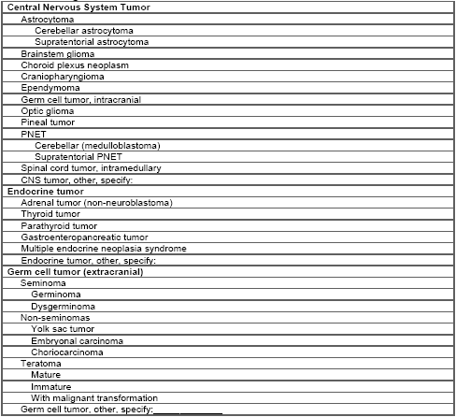

Creatinine
Age | Male | Female
2–3 years | 0.2–0.7 (17.7–61.9) | 0.3–0.6 (26.5–53.0)
4–7 years

Creatinine
2–3 years 0.2–0.7 (17.7–61.9) 0.3–0.6 (26.5–53.0)
4–7 years 0.2–0.8 (17.7–70.7) 0.2–0.7 (17.7–61.9)
8–10 years 0.3–0.9 (26.5–79.6) 0.3–0.8 (26.5–70.7)
11–12 years 0.3–1.0 (26.5–88.4) 0.3–0.9 (26.5–79.6)
13–17 years 0.3–1.2 (26.5–106.1) 0.3–1.1 (26.5–97.2)
18–20 years 0.5–1.3 (44.2–115.0) 0.3–1.1 (26.5–97.2)
Alkaline phosphatase
2–5 years 115–391 115–391
6–7 years 115–460 115–460
8–9 years 115–345 115–345
10–11 years 115–336 115–437
12–13 years 127–403 92–336
14–15 years 79–446 78–212
16–18 years 58–331 35–124
Phosphorus
1 year: 3.8–6.2 mg/dL (1.23–2.0 mmol/L)
10 years: 3.6–5.6 mg/dL (1.16–1.81 mmol/L)
Adults: 3.1–5.1 mg/dL (1.0–1.65 mmol/L)

