Patient Case Report Form

Pharmacogenetic analysis in pediatric/adolescent
Hematologic-oncologic disease

Principal Investigator:

1. BASIC DATA
Organization | _______________________________
Subject No. | _______________________________
Sex | ____________M / F_______________
Date of Birth :
 | YEAR |  |  |  |  | MONTH |  |  | DAY

2. DIAGNOSIS
Diagnosis | _______________________________(see #1)
Date of Initial Diagnosis :
 | YEAR |  |  |  |  | MONTH |  |  | DAY

3. TREATMENT

Date of Treatment start :
 | YEAR |  |  |  |  |  |  |  |  | MONTH |  |  |  |  |  | DAY
Date of Therapy completed:
(마지막 항암치료일) |  |  |  | YEAR |  |  |  |  |  |  | MONTH |  |  |  |  |  | DAY

Chemotherapy History
(ex. “0601 consolidation” “maintenance #1, #2”, not “HR 0601”)

Protocol | Start date | End date

4. Medication History
약품명 | 투여용량 | 투여경로 | 단위 | 처방시작일 | 처방종료일

5. Laboratory History
Use following Lab:
Amylase, ANC, aPTT, BUN, Ca, Cholesterol, Cr, Direct Bilirubin, Glu, GOT (AST), GPT (ALT), Hb, K, Lipase, Magnesium, Na, P, Phosphorus, PLT, PT, Total Bilirubin, Triglyceride, Uric acid, WBC, cardiac troponin I, NT-proBNP, CK-MB
검사일 | 검사명 | 검사결과 | 검사단위

6. 신체계측

측정일 | Body weight | Height | BSA

7. Adverse Events (CTCAE 4.0)

Lab test related Adverse Event

*Use following lab:
Complete Blood Counts: Anemia (Hb), Leukopenia (WBC), Neutropenia (ANC), Thrombocytopenia (PLT)
Chemistry & Coagulation & Urine: aPTT 연장, PT INR 증가, ALT or GPT 증가, AST or GOT 증가, Bilirubin 상승, Cholesterol증가, Creatinine 상승, Amylase 증가, Lipase 증가, Ca 증가, Ca 감소, Glucose 증가, Glucose 감소, K 증가, K 감소, Mg 증가, Mg 감소, Na 증가, Na 감소, TG 증가, Uric acid 증가, Albumin 감소, P 감소, cardiac troponin I, NT-proBNP, CK-MB
발생일 | 검사분류* | 검사관련 이상반응* | Adverse Event Grade
 | Complete Blood Counts  Chemistry & Coagulation & Urine |  | Gr3  Gr4
 | Complete Blood Counts  Chemistry & Coagulation & Urine |  | Gr3  Gr4
 | Complete Blood Counts  Chemistry & Coagulation & Urine |  | Gr3  Gr4
 | Complete Blood Counts  Chemistry & Coagulation & Urine |  | Gr3  Gr4

Symptom related Adverse Event

*Use following symptoms/diseases:
Allergy & Rash: Allergic reaction, Anaphylaxis, Injection site reaction, Rash maculo-papular, Urticaria, Stevens-Johnson syndrome
Fever & Infection: Febrile neutropenia, Fever without neutropenia, Sepsis
Cardiovascular: Ejection fraction 감소, Heart failure, Hypertension, Hypotension, Myocarditis, Pericardial effusion, Pericarditis, Thromboembolic event
Gastrointestinal: Constipation, Diarrhea, Hepatic failure, Ileus, Mucositis oral, Pancreatitis, Gastrointestinal hemorrhage
Neurologic: Encephalopathy, Leukoencephalopathy, Peripheral motor neuropathy, Peripheral sensory neuropathy, Seizure
Other: Pneumonitis, Avascular necrosis, Cytokine releasing syndrome, Osteonecrosis of jaw, Osteoporosis, Cataract, Hearing impaired, Blurred vision, Other disorders - specify
발생일 | 분류 | 질병관련 이상반응 | 발생여부 | NTCAE grade
 | Allergy & Rash  Fever & Infection  Cardiovascular  Gastrointestinal  Neurologic  Other |  | Yes  NO | Grade 1  Grade 2  Grade 3  Grade 4  Grade 5  Not known
 | Allergy & Rash  Fever & Infection  Cardiovascular  Gastrointestinal  Neurologic  Other |  | Yes  NO | Grade 1  Grade 2  Grade 3  Grade 4  Grade 5  Not known
 | Allergy & Rash  Fever & Infection  Cardiovascular  Gastrointestinal  Neurologic  Other |  | Yes  NO | Grade 1  Grade 2  Grade 3  Grade 4  Grade 5  Not known

Adverse Events Reference (CTCAE 4.03)

Complete Blood Counts | Grade 3 | Grade 4 | 발생일 | Gr3/Gr4
Anemia (Hb) | Hgb <8.0 g/dL or <4.9 mmol/L or <80 g/L
Leukopenia (WBC) | 1000 - 2000/mm³ or 1.0 - 2.0 x 10⁹ /L | <1000/mm³ or <1.0 x 10⁹ /L
Neutropenia (ANC) | 500 - 1000/mm³ or 0.5 – 1.0 x 10⁹ /L | <500/mm³ or <0.5 x 10⁹ /L
Thrombocytopenia (PLT) | 25,000 - 50,000/mm³ or 25.0 - 50.0 x 10⁹ /L | <25,000/mm³; <25.0 x 10⁹ /L
Chemistry & Coagulation  & Urine | Grade 3 | Grade 4 | 발생일 | Gr3/Gr4
aPTT 연장 | >2.5 x ULN; hemorrhage | -
PT INR 증가 | >2.5 x ULN | -
ALT or GPT 증가 | 5.0 - 20.0 x ULN | 20.0 x ULN
AST or GOT 증가 | 5.0 - 20.0 x ULN | 20.0 x ULN
Bilirubin 상승 | 3.0 - 10.0 x ULN | 10.0 x ULN
Cholesterol증가 | 400 - 500 mg/dL or 10.34 - 12.92 mmol/L | >500 mg/dL or >12.92 mmol/L
Creatinine 상승 | 3.0 - 6.0 x ULN | >6.0 x ULN
Amylase 증가 | 2.0 - 5.0 x ULN | >5.0 x ULN
Lipase 증가 | 2.0 - 5.0 x ULN | >5.0 x ULN
Ca 증가 | Corrected serum calcium of 12.5 - 13.5 mg/dL or 3.1 - 3.4 mmol/L  or Ionized calcium 1.6 - 1.8 mmol/L | Corrected serum calcium of >13.5 mg/dL or >3.4 mmol/L  or Ionized calcium >1.8 mmol/L
Ca 감소 | Corrected serum calcium of 6.0 - 7.0 mg/dL or 1.5-1.75 mmol/L  or Ionized calcium 0.8 - 0.9 mmol/L | Corrected serum calcium of <6.0 mg/dL or <1.5 mmol/L  or Ionized calcium <0.8 mmol/L
Glucose 증가 | 250 - 500 mg/dL or 13.9 - 27.8 mmol/L | >500 mg/dL or >27.8 mmol/L
Glucose 감소 | 30 - 40 mg/dL or 1.7-2.2 mmol/L | <30 mg/dL or <1.7 mmol/L
K 증가 | 6.0 - 7.0 mmol/L | >7.0 mmol/L
K 감소 | 2.5 - 3.0 mmol/L | <2.5 mmol/L
Mg 증가 | 3.0 - 8.0 mg/dL or 1.23 - 3.30 mmol/L | >8.0 mg/dL or >3.30 mmol/L
Mg 감소 | 0.7 - 0.9 mg/dL or 0.3 - 0.4 mmol/L | <0.7 mg/dL or <0.3 mmol/L
Na 증가 | 155 - 160 mmol/L | >160 mmol/L
Na 감소 | 120 - 130 mmol/L | <120 mmol/L
TG 증가 | 500 - 1000 mg/dL or 5.7 - 11.4 mmol/L | >1000 mg/dL or >11.4 mmol/L
Uric acid 증가 | ULN - 10 mg/dL (0.59 mmol/L) | >10 mg/dL or >0.59 mmol/L
Albumin 감소 | <2 g/dL, <20 g/L
P 감소 | 1.0 – 2.0 mg/dL or 0.3 – 0.6 mmol/L | <1.0 mg/dL or <0.3 mmol/L
cardiac troponin I | Levels above UNL
NT-proBNP | Levels above UNL
CK-MB | Levels above UNL

Allergy & Rash |  | Definition | Grade 1 | Grade 2 | Grade 3 | Grade 4 | Grade 5
Allergic reaction
Anaphylaxis
Injection site reaction
Rash maculo-papular
Urticaria
Stevens-Johnson syndrome
Fever & Infection |  | Definition | Grade 1 | Grade 2 | Grade 3 | Grade 4 | Grade 5
Febrile neutropenia
Fever without neutropenia
Sepsis
Cardiovascular |  | Definition | Grade 1 | Grade 2 | Grade 3 | Grade 4 | Grade 5
Ejection fraction 감소
Heart failure
Hypertension
Hypotension
Thromboembolic event
Gastrointestinal |  | Definition | Grade 1 | Grade 2 | Grade 3 | Grade 4 | Grade 5
Diarrhea
Hepatic failure
Ileus
Mucositis oral
Pancreatitis
Lower Gastrointestinal hemorrhage
Upper Gastrointestinal hemorrhage
Respiratory |  | Definition | Grade 1 | Grade 2 | Grade 3 | Grade 4 | Grade 5
Pneumonitis
Retinoic acid syndrome
Pulmonary fibrosis
Bronchopulmonary hemorrhage
Bronchospasm
Neurologic |  | Definition | Grade 1 | Grade 2 | Grade 3 | Grade 4 | Grade 5
Encephalopathy
Leukoencephalopathy
Peripheral motor neuropathy
Peripheral sensory neuropathy
Seizure
Renal, urinary |  | Definition | Grade 1 | Grade 2 | Grade 3 | Grade 4 | Grade 5
Acute kidney injury
Thrombotic thrombocytopenia purpura
Hemolytic uremic syndrome
Cystitis noninfective
Others |  | Definition | Grade 1 | Grade 2 | Grade 3 | Grade 4 | Grade 5
Avascular necrosis
Osteonecrosis of jaw
Osteoporosis
Cataract
Hearing impaired
Blurred vision
Psychosis
Other disorders - specify

8. LAST FU

Event
□ No
□ Relapse
Date of Relapse
 | YEAR |  |  |  |  | MONTH |  |  | DAY
□ Death
Date of Death
 | YEAR |  |  |  |  | MONTH |  |  | DAY
□ 2ndary malignancy or MDS, diagnosis _____________________(see #1)

Date of Diagnosis
 | YEAR |  |  |  |  | MONTH |  |  | DAY

Survival
□ Alive
□ Dead, cause of death ________________________________________
□ Related with drug adverse event
□ Not related

Date of last FU
 | YEAR |  |  |  |  | MONTH |  |  | DAY

#1. Diagnosis
1 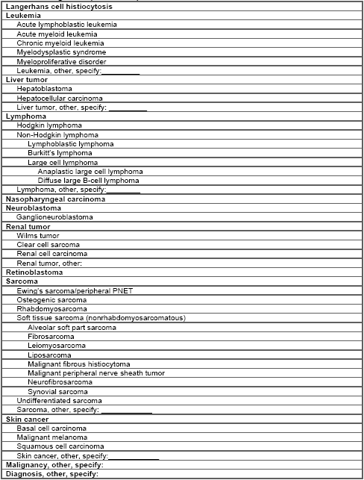
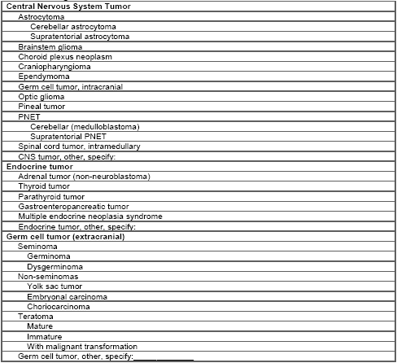

Creatinine
2–3 years 0.2–0.7 (17.7–61.9) 0.3–0.6 (26.5–53.0)
4–7 years 0.2–0.8 (17.7–70.7) 0.2–0.7 (17.7–61.9)
8–10 years 0.3–0.9 (26.5–79.6) 0.3–0.8 (26.5–70.7)
11–12 years 0.3–1.0 (26.5–88.4) 0.3–0.9 (26.5–79.6)
13–17 years 0.3–1.2 (26.5–106.1) 0.3–1.1 (26.5–97.2)
18–20 years 0.5–1.3 (44.2–115.0) 0.3–1.1 (26.5–97.2)
Alkaline phosphatase
2–5 years 115–391 115–391
6–7 years 115–460 115–460
8–9 years 115–345 115–345
10–11 years 115–336 115–437
12–13 years 127–403 92–336
14–15 years 79–446 78–212
16–18 years 58–331 35–124
Phosphorus
1 year: 3.8–6.2 mg/dL (1.23–2.0 mmol/L)
10 years: 3.6–5.6 mg/dL (1.16–1.81 mmol/L)
Adults: 3.1–5.1 mg/dL (1.0–1.65 mmol/L)

